Inheritances In JAVA

Multilevel Inheritance

Code: --

class state{

String st;

public state() {

String st = "Harayana";

System.out.println("Inside class state");

}

}

class city extends state{

String cit;

int pin;

public city(){

cit ="Faridabad";

pin=121004;

System.out.println("Inside class city");

}

}

class Aniruddha_015 extends city{

String name;

String reg;

public Aniruddha_015(){

name = "Aniruddha";

reg = "RA2112704010015";

System.out.println("Inside class Aniruddha-015");

}

}

public class mulitlevel_inheritence {

public static void main(String[]args){

Aniruddha_015 obj = new Aniruddha_015();

System.out.println("My name is "+obj.name);

System.out.println("My Registration number is "+obj.reg);

System.out.println("I am from "+obj.cit +"city whose pin code is "+obj.pin);

System.out.println("I am from "+obj.st+" State ");

}

}

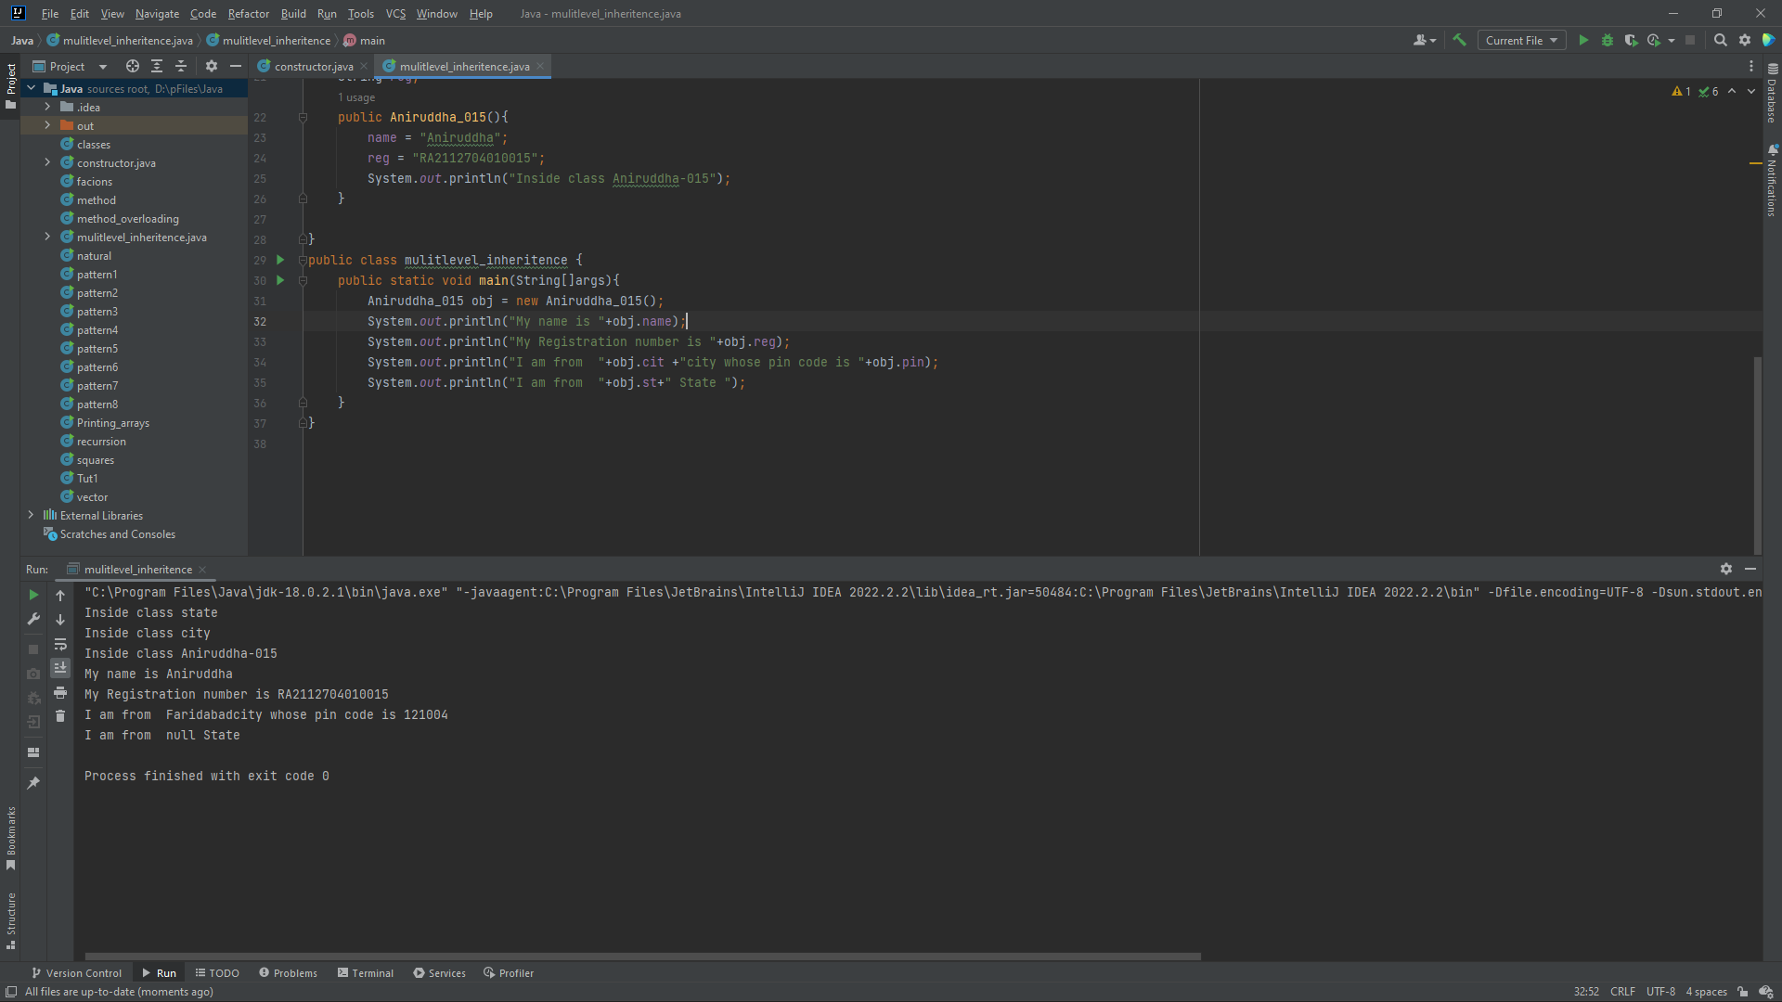

Hierarchical Inheritance

Code: --

class uni{

String name;

public uni(){

name ="SRM UNIVERSITY";

}

}

class ist extends uni{

String dept ="COLLEGE OF COMPUTING";

public ist (){

System.out.println(dept+"is in "+name);

}

}

class mang extends uni{

String dep ="COLLEGE OF MANAGEMENT";

public mang (){

System.out.println(dep+"is in "+name);

}

}

public class hierarchical {

public static void main(String args[]){

ist obj1 = new ist();

mang obj2 = new mang();

}

}

